Task1: Introduction to Docker containers and DockerHub

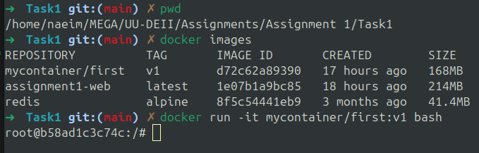
apt-get update
apt-get install -y lsb-release
lsb_release -a
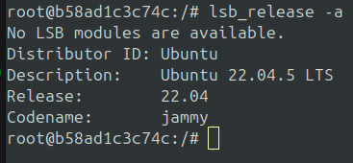

Question:
1 - Explain the difference between contextualization and orchestration processes.

2 - Explain the followings commands and concepts:
- Contents of the docker file used in this task.
- Explain the command:
  - docker run -it mycontainer/first:v1 bash

- Show the output and explain the following commands:

  - docker ps
  - docker images
  - docker stats

3 - What is the difference between dockerbuild commands?

4 - Create an account on DockerHub and upload your newly built container to your DockerHub area. Explain the usability of DockerHub. Make your container publicly available and report the name of your publicly available container.

5 - Explain the difference between docker build and docker compose commands.

Task 2. Build a multi-container Apache Spark cluster using docker compose

Questions
1 - Explain your docker compose configuration file.
2 - What is the format of the docker compose compatible configuration file?
3 - What are the limitations of docker compose?

Task 3. Introduction to different orchestration and contextualization frameworks
Write an essay on the role of runtime orchestration and contextualization for large scale distributed applications. Briefly discuss the features and design philosophy of at least four relevant frameworks. In Task 2, you have orchestrated a multi-container Spark cluster using docker compose. Discuss how the features of frameworks like Kubernetes and Docker Swarm can improve your current solution for providing a Spark cluster. The expected length of the easy will be one A4 page 11 pt Arial.

